**What is the history of Human Resource Management(HRM)?**

Human Resource management is perceived by many as a relatively new invention. Nonetheless, an examination of the field's past indicates that the concepts guiding it date back to the beginning of human history. The optimization of employee potential and personnel management have long been concerns. The 18th century saw the beginning of the practice of human resources management, which culminated in the creation of human resources departments today.

Through the interview process, employees frequently get to meet HR personnel even before they start working for the company. HR is typically in charge of hiring, acquiring, and onboarding new hires as well as helping them during their first few months of employment.

Unfairly, "HR" is frequently the last department acknowledged for a company's accomplishments and the first one called upon in times of need. Since it's an employee's first and probably last point of contact with the company, the human resources department at a company has a greater responsibility than any other to ensure employee success and, by extension, corporate success.

So, where did the concept for a **"human resources"** department come from? How did it evolve? And where is it going—possibly the most crucial question? This blog explores, the rich history of Human Resource Management (HRM) from ancient practices to modern strategies and from rest of the world to India.

‍**Historical Background Of Human Resources**

The history of human resources (HR) traces back to 19th-century Europe, championed by thinkers like Robert Owen and Charles Babbage who emphasized the importance of employee well-being for organizational success. Influenced by Frederick Winslow Taylor, HR evolved into a distinct discipline in the early 20th century, focusing on scientific management and productivity. Concurrently, C.S. Myers laid the groundwork for the human relations movement, highlighting non-monetary stimuli's impact on productivity through studies like the Hawthorne experiments.

As the business landscape evolved due to figures like Andrew Carnegie and public policies like the New Deal, employer-employee relationships transformed, leading to the formalization of HR management (HRM) as "industrial and labor relations." Professional HR associations, such as the Chartered Institute of Personnel and Development (CIPD) and the Society for Human Resource Management (SHRM), emerged to support the field's growth.

In the Soviet Union, Stalin's regime recognized the strategic importance of human resources, implementing HR policies alongside technical management. In the United States, institutions like the School of Industrial and Labor Relations at Cornell University and publications like The Journal of Personnel Research furthered HR research and education.

Throughout the 20th century, HR practices adapted to changing needs, with a shift towards viewing employees as assets and the dominance of the term "human resources management" (HRM). This term encompasses various aspects of workforce management, including talent management, organizational management, and personnel management.

As transportation and communication advanced, facilitating workforce mobility and collaboration, HRM continued to evolve, with a focus on human capital management (HCM) emphasizing individuals' knowledge contribution to organizations.

The human relations movement of the early 20th century gave rise to HR, when scholars started recording methods of generating economic value via the strategic management of labor forces. HR was once primarily concerned with transactional tasks like payroll and benefits administration, but in 2024, as a result of technological advancements, company consolidation, globalization, and additional research, the field will be more focused on strategic initiatives like succession planning, talent management, mergers and acquisitions, industrial and labor relations, diversity and inclusion, and talent management. Most businesses prioritize reducing employee turnover and keeping their workforce's expertise and knowledge in the present global work environment.

The historical treatment and management of different categories of labor are significant in understanding the evolution of human resource management.

* **Managing Slaves:** In ancient civilizations, slaves were treated as commodities, bought by rulers, landlords, tribal chiefs, and wealthy businessmen. Masters had complete control over slaves who performed arduous tasks like heavy lifting, rowing, construction, and farming in exchange for basic necessities. Slaves faced strict supervision, and disobedience often resulted in physical punishment or even death.
* **Managing Serfs:** During feudal times, serfs were employed by landlords primarily for agriculture. They were given land for dwelling and cultivation but were obligated to serve their masters. Serfs could be freed after returning the land and repaying advances. Despite authoritarian management, some landlords developed personal relationships with serfs, offering economic incentives and resolving grievances.
* **Managing Indentured Labor:** With mercantilism and industrialization, there was a surge in demand for skilled labor. Employers attracted workers with incentives for increased productivity. Industrialization led to large-scale employment, with employers focused on profits and often neglecting worker welfare.

Over time, worker awareness grew, leading to collective action through trade unions. Early labor movements faced legal challenges but eventually led to changes in employer-employee relationships. Factors like democratic ideals, socialist ideas, and the emergence of welfare states influenced labor laws, improving working conditions and workers' rights.

**The evolution of Human Resource Management (HRM) has been influenced by historical eras:**

* **Industrial Revolution Era:** Saw the emergence of systematic HRM practices focused on recruitment, training, and control of workers.
* **Trade Union Movement Era:** Workers organized to address common issues, leading to the adoption of grievance handling systems and improved employee benefits.
* **Social Responsibility Era:** Some employers adopted a paternalistic approach, offering concessions and welfare schemes to manage labor unrest.
* **Scientific Management Era:** Introduced efficiency-focused methods like time studies to enhance productivity.
* **Human Relations Era:**Highlighted the importance of human factors at work, emphasizing social aspects and employee relations.
* **Behavioral Science Era:** Explored human behavior in organizations, promoting self-direction and participation.
* **Systems and Contingency Approach Era**: Focused on holistic management of HR based on empirical data.

Today's HRM emphasizes the socio-psychological aspects of employees as crucial for organizational effectiveness. The term "Human Resource Management" has replaced "Personnel Management," reflecting a contemporary view of employees as strategic assets in organizations. This evolution reflects broader societal changes and ongoing efforts to balance employer interests with worker welfare.

The evolution of Human Resource Management can be traced through distinct historical stages that have shaped the discipline into what it is today.

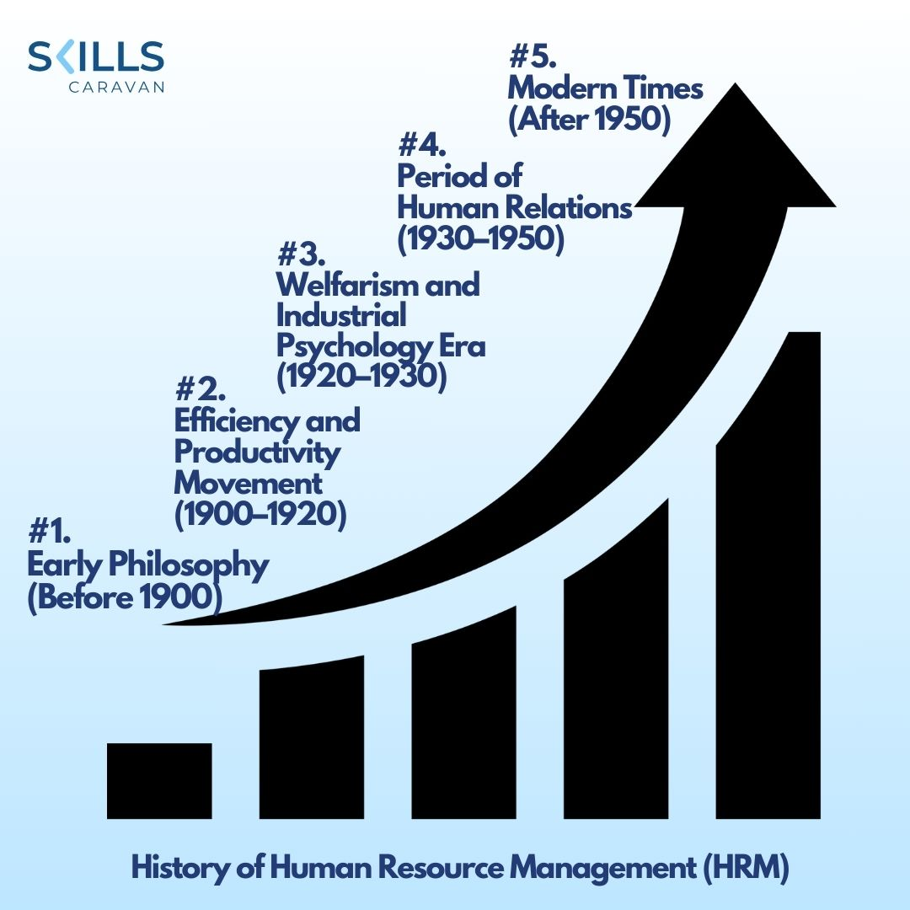

History of Human Resource Management

**#1. Early Philosophy (Before 1900):**

Robert Owen's initiatives laid the groundwork for current Human Resource Management. Owen, who is sometimes called the father of HRM, first presented his theories in 1813 in his book "A New View of Society." He underlined how crucial it is to strengthen service conditions and industrial relations. Owen was friendly, liberal, and paternalistic in his treatment of laborers. Alongside his business, he constructed high-quality housing for his workers, did away with child labor, and made sure the workplaces were safe. Contemporaries who supported ideas like wage incentives, profit-sharing, and labor welfare, including J.S. Mill, Andrew Yule, and Charles Bewarage, also contributed to the development of HRM as a discipline.

**#2. Efficiency and Productivity Movement (1900–1920):**

The efficiency and productivity movement began to take shape between 1900 and 1920. Taylor's introduction of scientific management ideas dominated this era. Around this time, Taylor's Scientific Management Thought—which promoted the use of scientific procedures in activities, job analysis, standards costing, and the scientific hiring and training of employees—became widely accepted. Taylor's opposition to workers' groups and trade unionism signaled a change in management philosophy toward a methodical and scientific approach.

**#3. The 1920–1930 Welfarism and Industrial Psychology Era:**

The basis of human resource management, staff line organization, had solidified into a recognizable shape by 1925. The demand for industrial psychology was sparked by opposition to the scientific management movement. Industrial psychologists revolutionized the field of human resource management by developing novel approaches like psychological testing, interviews, worker training, and non-cash incentives. As a result, HRM became a specialized role.

**#4. Period of Human Relations (1930–1950):**

Prof. Elton Mayo and associates' Hawthorne experiments signaled the start of a new era in which the significant impact of human resources on productivity was acknowledged. During this time, it was stressed how important it is to treat employees as unique people with moral, psychological, and social requirements. From seeing labor as a commodity to seeing it as a social phenomenon, concepts changed. The 1940s and 1950s saw the emergence of new methods for hiring, onboarding, and training employees as well as an increase in the focus on people-oriented management, trade union growth, and the expansion of fringe benefits.

**#5. Modern Times (After 1950):**

Post-1950, Human Resource Management entered a phase of modern development centered around the citizenship concept of labor. Workers gained increased rights and involvement in decision-making processes. The notion of industrial democracy imposed new responsibilities on human resource managers, expanding the discipline's scope. Since the 1960s, Human Resource Management evolved into a behavioral science focusing on human elements and organizational behavior. The belief in 'open social and industrial systems' gained traction in the 1970s, further shaping Human Resource Management as a recognized profession managing human resources within organizations.

The history of Human Resource Management reflects a dynamic evolution from its early philosophical roots to its current state as an interdisciplinary field encompassing organizational behavior, personnel management, industrial relations, and labor legislation. As it continues to evolve, HRM remains responsive to the changing needs and dynamics of modern workplaces.

‍

**History of Human Resource Management in India**

Human Resource Management in India has evolved over centuries, with historical references such as those found in the Arthasastra indicating early job descriptions for supervisors and the implementation of performance-linked pay for goldsmiths. Traditional craft goods were exported to Europe, highlighting a master-servant relationship prevalent in the 17th century.

**There were more important turning points in the evolution:**

Robert Owen, who is regarded as the founder of the cooperative movement, released "A New View of Society" in 1828 and argued in favor of better living and working circumstances for laborers.

Formal personnel management systems were made possible by the institutional frameworks for administration that were constructed by British monarchs from 1850.

The Industrial Revolution and a rising consciousness of worker rights coincided with the Royal Commission of Labor’s significant impact in 1931 in shaping government views on labor.

The first tripartite labor conference was held in 1941, and the Factories Act was passed in 1948, highlighting cultural and social changes that changed how people saw labor and managerial values in the 1950s and 1960s.

India's economic strategies, including the Five-Year Plans from 1950 to 1969, involved both private and public sector initiatives. Post-1990, the focus shifted towards human values and productivity through people-centric approaches, notably seen in public sector companies like BHEL, SAIL, and SBI.

**Subsequent years emphasized:**

Progressive HR efforts in 1995.

A customer-centric approach from 1997 onward, fostering customer satisfaction, benchmarking, core competencies, empowerment, and the development of learning organizations.

This evolution marked a transition from conventional labor relations and personnel management towards Human Resources Management (HRM), Human Capital Management (HCM), and ultimately Strategic HRM, aligning HR practices with organizational objectives and the broader business strategy.

‍**3 Ways that current HR Managers adds value to a organization**

**1. Employee Training and Development:**

HR invests significantly in training to equip staff with new skills and processes, fostering continuous growth throughout their employment. Training is no longer a one-time event but an ongoing process integrated into the employee lifecycle.

**2. Competitive Analysis and Benchmarking:**

Similar to how companies analyze market competition, HR assesses talent competition. By benchmarking against industry rivals, HR ensures the organization remains attractive to prospective employees, mirroring competitive strategies used in product and service markets.

**3. Increasing Employee Engagement:**

HR focuses on enhancing employee commitment, clarity of purpose, and job satisfaction. Engaged employees are more productive and contribute to higher revenue and profits. HR endeavors to boost engagement through retention efforts, ultimately driving organizational success.

In summary, modern HR strategies align training, competitive analysis, and engagement efforts to enhance business value and competitiveness.

‍**Future of HRM**

In today's rapidly evolving landscape of Human Resource Management (HRM), technological advancements and changing work dynamics are reshaping the role of HR professionals. Beyond traditional administrative tasks, they now engage in strategic planning, data analysis, and nurturing dynamic workplace cultures. Looking ahead, several trends emerge:

* **Technology and Automation:** Automation and AI streamline HR processes, enhancing efficiency but also raising concerns about job displacement and the need for upskilling.
* **Remote Work and Flexibility:** The pandemic accelerated remote work adoption, prompting HR to manage remote teams effectively and prioritize employee well-being.
* **Employee Well-being and Mental Health:** HR emphasizes holistic wellness, implementing initiatives for work-life balance and mental health support.
* **Diversity, Equity, and Inclusion (DEI):** Organizations prioritize creating inclusive workplaces, with HR ensuring policies promote diversity and equal opportunities.
* **Continuous Learning and Upskilling:** HR fosters a culture of lifelong learning, identifying skill gaps and offering relevant training.
* **Data-Driven Decision Making:**HR leverages data insights for informed decision-making, balancing privacy and ethical concerns.
* **Agile Performance Management:** Regular feedback and goal-setting replace traditional performance reviews, fostering open communication and enhancing employee performance.
* **Remote Onboarding and Company Culture:** HR innovates virtual onboarding processes and remote team-building activities to integrate new hires into company culture effectively.

‍**Conclusion**

In tracing the history of Human Resource Management (HRM), it becomes evident that its roots extend far back, with concerns for employee well-being and productivity emerging as early as the 19th century. The [evolution of HRM](https://www.skillscaravan.com/post/the-evolution-of-hrm-understanding-its-features-objectives-and-characteristics) from scientific management to the human relations movement and its subsequent formalization into industrial and labour relations reflect the changing dynamics of employer-employee relationships. Professional associations and academic institutions played pivotal roles in advancing HRM as a distinct discipline. As we delve into the current landscape, it's clear that HRM has evolved beyond its administrative functions, embracing strategic planning, data analytics, and fostering inclusive workplace cultures. The future of HRM is marked by technological advancements, remote work dynamics, emphasis on employee well-being, diversity, and continuous learning. By aligning with these trends and focusing on value-added initiatives like employee training, competitive analysis, and engagement efforts, modern HRM strategies aim to enhance business value and competitiveness in the evolving global landscape.

‍

History of Human Resource Management(HRM) FAQs

Q: What is the history of Human Resource Management (HRM)?

Q: Who were the key influencers in the evolution of HRM?

Q: How did the concept of HRM evolve over time?

Q: What were the significant milestones in HRM's history?

Q: How did historical eras influence the development of HRM?

Q: What are the key differences between HRM and Personnel Management?

Q: How has HRM adapted to modern challenges like globalization and technological advancements?

Q: What role did key figures like Andrew Carnegie and C.S. Myers play in HRM's evolution?

Q: How does HRM align with contemporary workplace dynamics and trends?

Q: What are the future prospects and trends in HRM?